# DSA LAB TASK 5

**NAME:** Omerullah Ansari

**STD ID:** 65584

**Task 1**

import random

def guess_number(lower, upper):

number = random.randint(lower, upper)

guesses = 0

low = lower

high = upper

while True:

guess = (low + high) // 2

print("Is your number", guess, "?")

response = input("Enter 'higher', 'lower', or 'correct': ").lower()

guesses += 1

if response == "higher":

low = guess + 1

elif response == "lower":

high = guess - 1

elif response == "correct":

print("Your number is", guess)

print("It took", guesses, "guesses.")

break

else:

print("Invalid response. Please enter 'higher', 'lower', or 'correct'.")

guess_number(1, 1000)

**OUTPUT:**

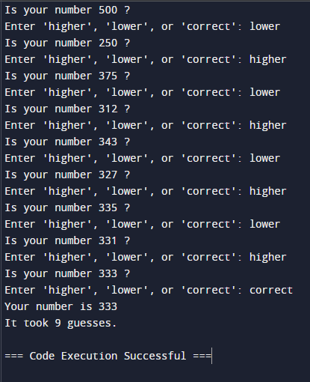

**TASK 2**

def matching_integers(integers, queries):

results = []

for query in queries:

count = 0

for num in integers:

if num == query:

count += 1

results.append(count)

return results

integers = [1, 1, 2]

queries = [1, 2, 3]

print(matching_integers(integers, queries))

**OUTPUT:**

